Group 7

SWE30010

PHP Database Manual



Table of Contents

Quick Start Guide 1

Login and Registration 1

Home Page 2

Alerts 3

Sales 4

Inventory 5

Reports & Exporting 5

Sales 6

Orders 7

# Quick Start Guide

After downloading and installing the application on your store machine select the **Startup.exe** file on your desktop.

## Login and Registration

1. A login screen will come up when the application is started. If you are already registered, **skip to step 3**. If you are a **new user**, click the **[SignUp]** button.   
   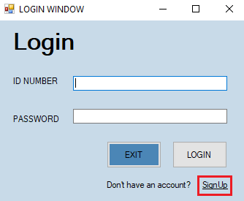
2. Fill-in your **registration** details and hit **[Register].**

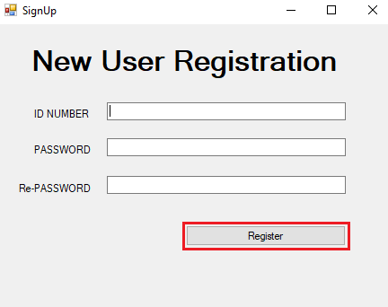

1. Fill-in your **login** details and hit **[Login].**

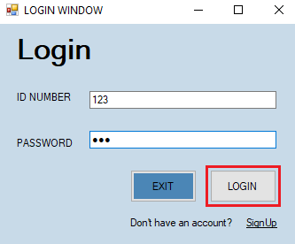

## Home Page

After successfully logging in, you will be taken to the **Home Page.** Review the following image to familiarise yourself with the available buttons and notifications.

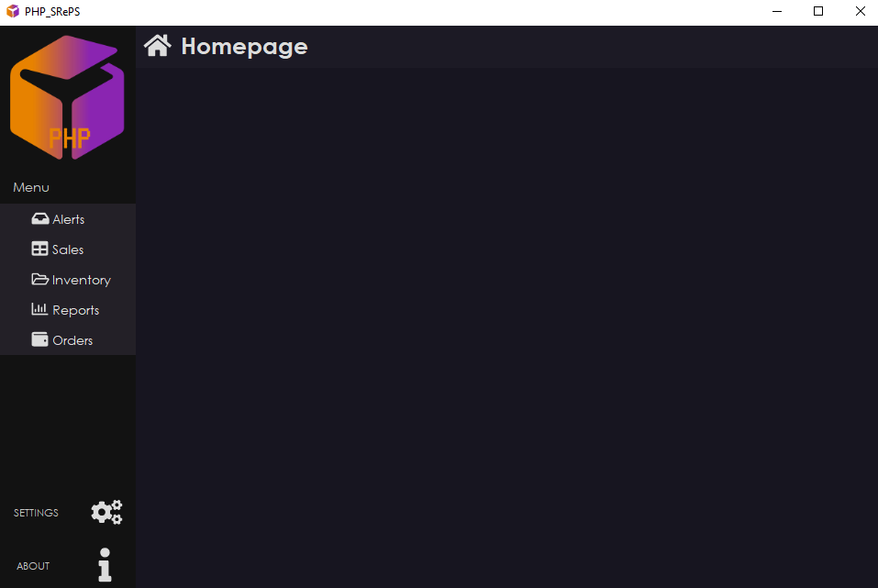

## Alerts

From the home screen, select **[Alerts]** under the **[Menu]** dropdown.

Products with Low Stock

Select the **[Products with Low Stock]** button. Notifications will automatically pop up, click **[OK]** to close the notifications.

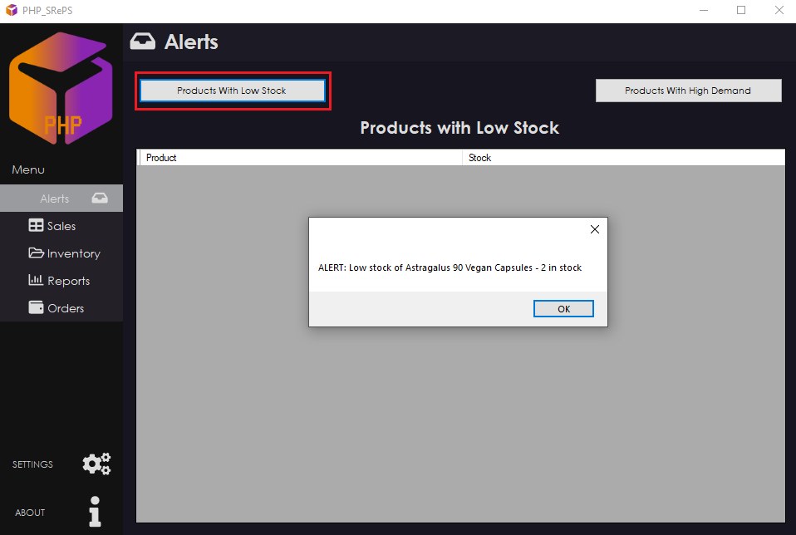  
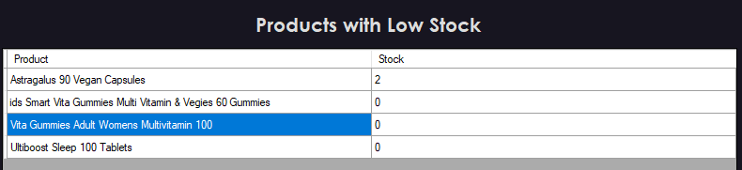

Products with High Demand

Select the **[Products with High Demand]** button. Notifications will automatically pop up, click **[OK]** to close the notifications.

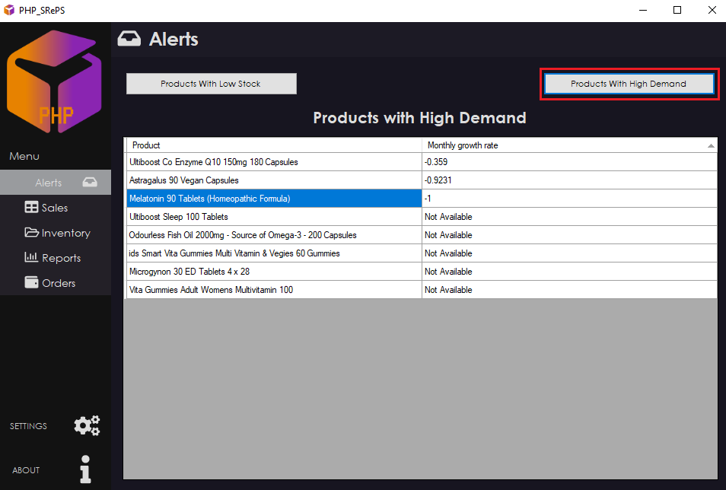

## Sales

From the home screen, select **[Sales]** under the **[Menu]** dropdown.

Adding Sales

1. To add a sale, select **[Add]** and fill in the sale details.

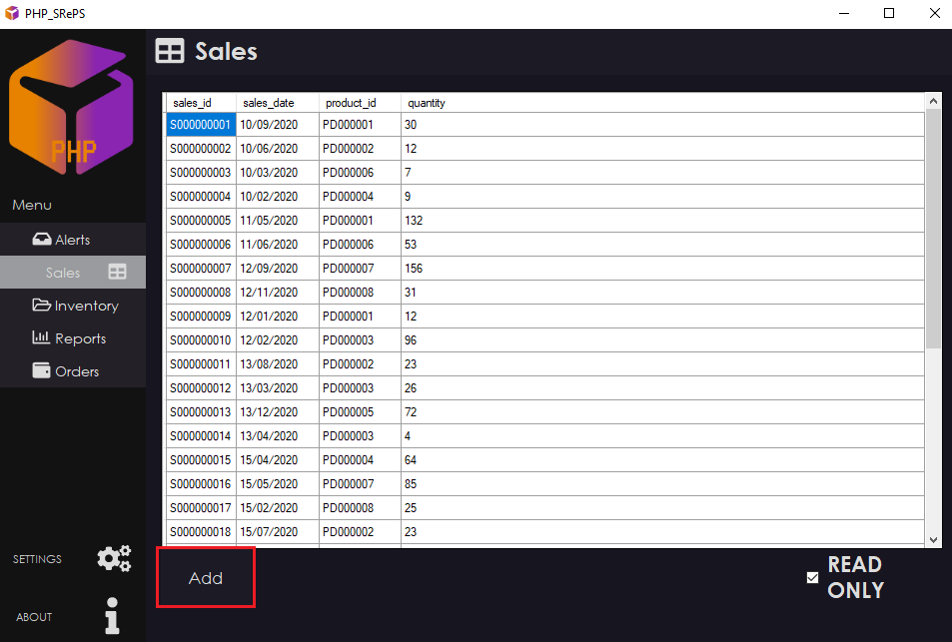

1. Click the **tick symbol** to log the sale. Click the **trashcan** to clear the entry. Click the **cross symbol** to exit the menu.

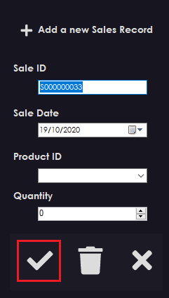

Editing Sales

1. To edit a sale, unselect the **[READ ONLY]** checkbox.
2. Click the associated column with the sale entry (row) to edit.
3. Select **[READ ONLY]** checkbox to avoid accidentally changing data.   
   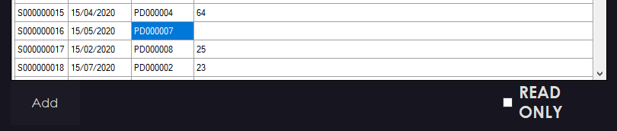

## Inventory

From the home screen, select **[Inventory]** under the **[Menu]** dropdown.

To have an accurate Inventory, users are required to log orders. The inventory is updated when a sale is logged- inventory will be automatically updated.

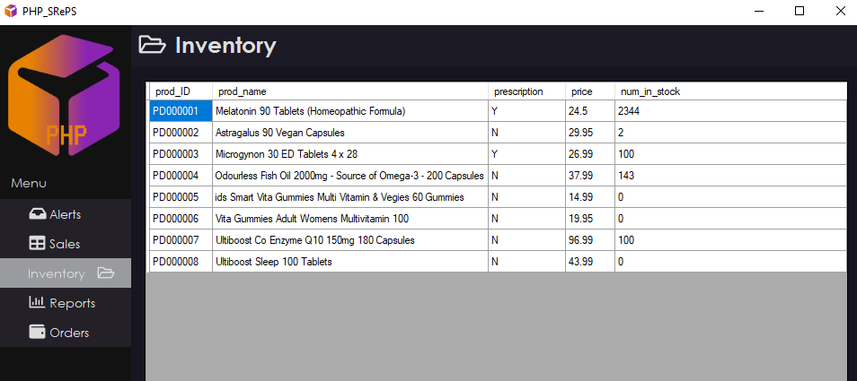

## Reports & Exporting

From the home screen, select **[Reports]** under the **[Menu]** dropdown.

Displaying Reports

Reports are generated for the month or all time. To view these, click the **[Display Monthly Sales Data]** or **[Display All Time product Sales].**

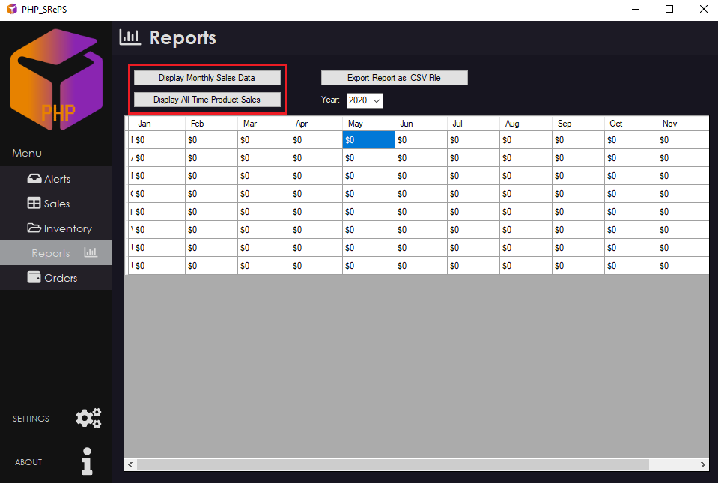

Exporting Reports

To export the data, click the **[Export Report as .CSV File].**

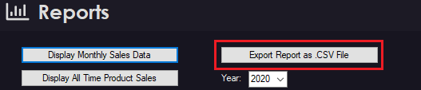

## Sales

From the home screen, select **[Sales]** under the **[Menu]** dropdown.

Adding Sales

1. To add a sale, select **[Add]** and fill in the sale details.



1. Click the **tick symbol** to log the sale. Click the **trashcan** to clear the entry. Click the **cross symbol** to exit the menu.



Editing Sales

1. To edit a sale, unselect the **[READ ONLY]** checkbox.
2. Click the associated column with the sale entry (row) to edit.
3. Select **[READ ONLY]** checkbox to avoid accidentally changing data.   
   

## Orders

From the home screen, select **[Orders]** under the **[Menu]** dropdown.

Adding Orders

1. To add a sale, select **[Add]** and fill in the sale details.



1. Click the **tick symbol** to log the sale. Click the **trashcan** to clear the entry. Click the **cross symbol** to exit the menu.



Editing Inventory

1. To edit an inventory log, unselect the **[READ ONLY]** checkbox.
2. Click the associated column with the inventory entry (row) to edit.

Select **[READ ONLY]** checkbox to avoid accidentally changing data.